Health impact assessment of air pollution in India and some of its cities
1.0 Introduction
Many epidemiological studies have documented that the short-term and long-term exposure to particulate matter (PM) has augmented the respiratory and cardiovascular mortality and morbidity and thus has resulted in reduced life expectancy (Hoek et al., 2013; Anderson et al., 2012; Rückerl et al., 2011; Pope et al., 2009; Zanobetti et al., 2009; Laden et al., 2006). Cardiovascular mortality as a result of chronic exposure to PM pollution occurs by pulmonary and systemic inflammation, accelerated atherosclerosis and altered cardiac autonomic function mechanisms (Pope et al., 2004). An ultrafine particle grasps into the brain through respiratory canal by sensory neurons and finally enters into blood and lymph. Leiva et al., 2013 have found that increase in hospital admissions related to cerebrovascular diseases are linked with exposure to higher levels of PM_{2.5}. The foremost damaging outcomes of chronic exposure to PM includes increased respiratory morbidity and symptoms such as chronic bronchitis and persistent cough and phlegm (Anderson et al., 2012; Rückerl et al., 2011; Pope et al., 2006; WHO, 2005; McConnell et al., 1999). While these consequences are not as grave as mortality for acute cardiopulmonary ailments, but they possibly have detrimental impact on human health and quality of life due to greater proportion of population suffering from chronic diseases and disorders (Ostro, 2005).
The children and elderly populations are probably more vulnerable than other proportion of population to harmful effects of exposure to PM due to physiological differences (Sacks et al., 2011). Children are at greater risk than adults to deleterious effect of PM due to greater amount of time spent in outdoor environment and minute volume per unit body weight, brain development associated with dynamic behavioural, cognitive and emotional changes. This upsurges the dose of PM per lung surface area and thus become more vulnerable to adverse effects. The elderly on the other hand are commonly deliberated a susceptible subpopulation due to continuous decay in physiological processes with the growing age. The elderly population in contrast to children and adults, have greater prevalence of pre-existing cardiovascular and respiratory diseases, which may also add vulnerability to PM. Studies have demonstrated that increased use of medicines, respiratory disorder symptoms and decrease in pulmonary functions are due to acute exposure to PM_{2.5} (Rabinovitch et al., 2006; Gent et al., 2003). Tsai et al. (2013) have reported that hospital admissions of chronic obstructive pulmonary disease (COPD) are positively correlated with higher PM_{2.5} pollution levels during summers and winters. Studies have shown that chronic exposure to fine PM pollution has resulted in increased lung cancer mortality (Turner et al., 2011; Pope et al., 2000). Exposure to higher levels of PM have also been known to associate with cardiovascular diseases such as myocardial infarction, heart failure and arrhythmia (Shah et al., 2013; Mustafic et al., 2012; Peters et al., 2000). Around 1,00,000 premature deaths are associated with exposure to air pollution (PHFI 2014) in India, and in Delhi, around 7350 to 16200 premature deaths have been reported as a result of PM exposure (Guttikunda & Goel, 2013). Every year 6-7 million deaths (one in eight of total global deaths) are occurring due to air pollution related diseases and this has made air pollution problem as the fourth largest global threat to human health after blood pressure (Energy & Air Pollution, IEA, 2016). The Global Burden of Disease (GBD) ranked ambient air pollution as one of the top ten causes of deaths across the world and sixth most dangerous killer across South Asia. Therefore, it becomes imperative to comprehensively understand the association between air pollution and its effects on human health. This would also advocate the process of formulating the policy inclined towards improved air quality and the strategies to reduce subsequently the impacts on human health.

2.0 Methodology
Epidemiological studies conducted in different parts of the world have demonstrated a wide range of acute and chronic health impacts due to air pollution. Some notable examples are studies carried out in Jakarta, Santiago, Mexico City, Shanghai, Taiwan, and China. Similar studies have also been carried out in India in Mumbai, Delhi, Hyderabad and Chandigarh. But, these epidemiological studies have used the concentration response (CR) functions developed by WHO and World Bank in U.S context, to quantify the disease burden and injury on human populations (WHO, 2002; Valent et al., 2004a, 2004b).
The study adopts World Health Organization methodology for the calculation of change in disease occurrence (ΔI) which has also been adopted by Gurjar et al. (2010). The first step of assessment comprises of attributable proportion (AP) calculation, which indicates the fraction of the health effects that can be attributed to the exposure in a given population (Eq. 1).
$AP=\frac{\sum{\left[\left\{{RR}_{C}-1\right\} ×p(c)\right]}}{\left\{{RR}_{C}×p(c)\right\}}$ ….1
Where; ${RR}_{C}$ is relative risk due to specific concentration which has been adopted from WHO study and $p(c)$ is the proportion of the target population in category ‘c’ of exposure. The ${RR}_{C}$ has been calculated as change in the relative risk due to change in pollutant concentration using Eq. 2 (adopted from Cairncross et. al., 2007).
$RRc=1+\left[\left(RR-1\right)×\left(C-T_{c}\right)\right]$ ….2
Where; C is resultant concentration and $T_{c}$ is threshold concentration. The excess cases ($ΔN)$ were calculated using Eq. 3.
$ΔN\left(c\right)= \left[\left(RRc-1\right)×p\left(c\right)×I ×\left(1-AP\right)\right]×N$ ….3
Where; N is the population and I is the baseline incidence for the said disease

In this study, only health impacts of PM_{2.5} have been estimated as it is the most important pollutant having impacts over human health. While, we understand that gaseous pollutant also have impacts over health, but the information on synergistic impacts of these pollutants is limited in the literature. Most health impact assessment studies like the ones carried out for assessment of global burden of diseases have also estimated impacts of PM_{2.5}.
Modelled gridded PM_{2.5} concentrations for India were obtained from Norwegian Meteorological Institute and population totals for Indian districts were estimated for different grids .The modelled gridded PM_{2.5} concentrations were then overlaid on gridded population data for different years. Using the dose response relationships discussed above, annual mortalities attributable to ambient air pollution in India are estimated.

3.0 Results and discussion
It is estimated that about 0.86 million people die prematurely in India due to exposure towards ambient PM_{2.5} concentrations in India. In the BAU scenario, without any consideration of new policies for control, the mortalities will increase to 1.5 million in 2030 and 2.1 million in 2050 (Figure 1). The increase in the BAU scenario is attributed to both increase in population and increased PM_{2.5} concentrations due to rising emissions in different sectors.

Figure 1: Total mortalities (millions) estimated due to PM_{2.5} concentrations in India in a BAU scenario
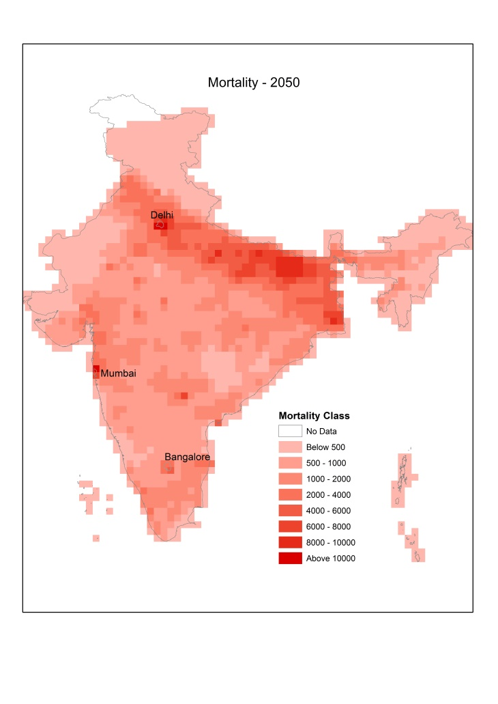
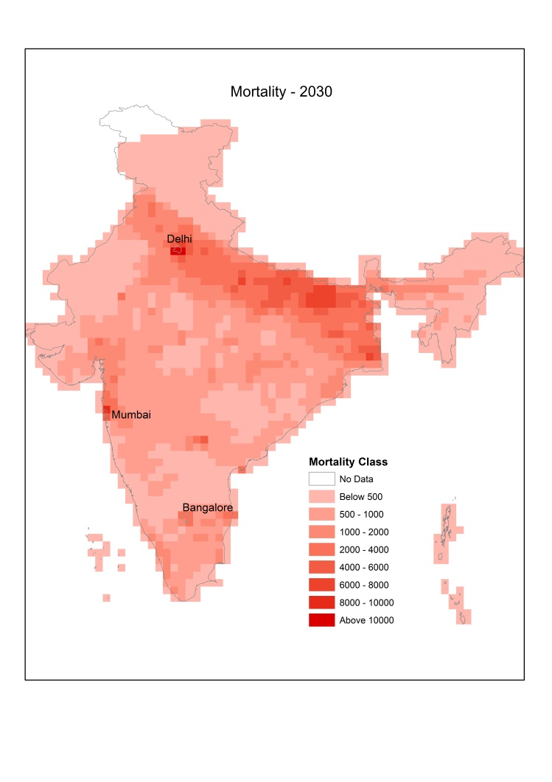
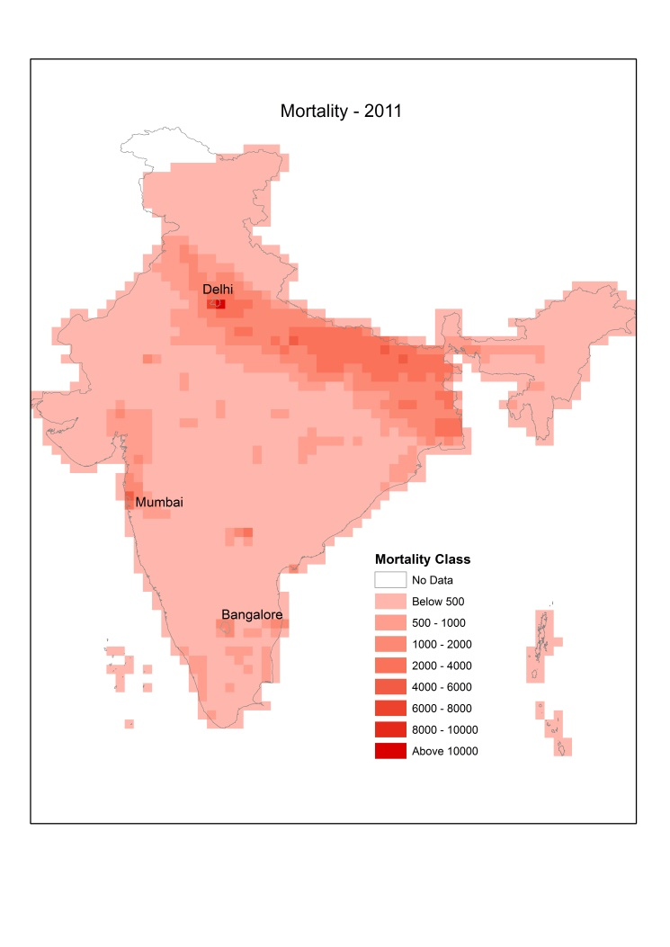
Figure 2-4 show the spatial distribution of mortalities across whole of India. It is evident that India-Gangetic plain, which is not only the most polluted region, but also the most populated one, shows highest mortalities in India due to air pollution. The figures also show considerable increase in mortalities in future years under a BAU scenario.

Figure 2-4: Spatial distribution of mortalities attributable to ambient air pollution in India in a BAU scenario.

The annual average PM2.5 concentrations in the three cities are shown in Figure 5. Delhi shows the highest PM2.5 concentrations among the 3 cities due to high emissions intensities in and around the city in the Indo-Gangetic plains.

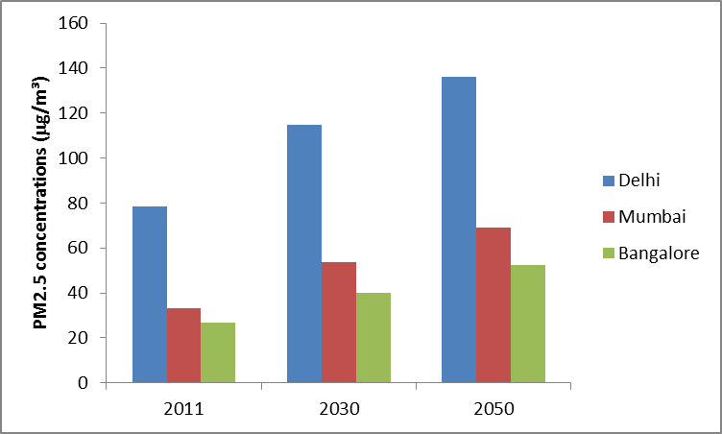

Figure 5: Annual average PM2.5 concentrations in 3 cities in India

Big cities like Delhi, Mumbai, and Bangalore have higher population densities and higher PM_{2.5} levels than the surroundings. The population in 3 cities in the baseline year 2011 and projections for future years are shown in Figure 6.
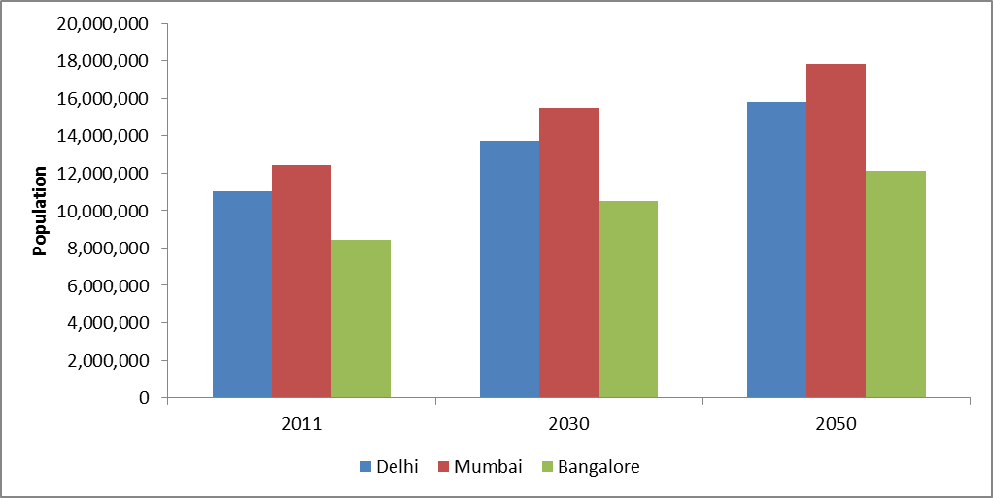
Figure 6 Population in three cities during different years

Consequently, these cities show higher mortalities than the surroundings. Figure 7 shows the mortalities estimated for the 3 selected cities for the baseline and future years in the BAU scenario. Annual mortalities were estimated to be 11707, 6109, and 3337, for Delhi, Mumbai and, Bangalore, respectively, for the year 2011.

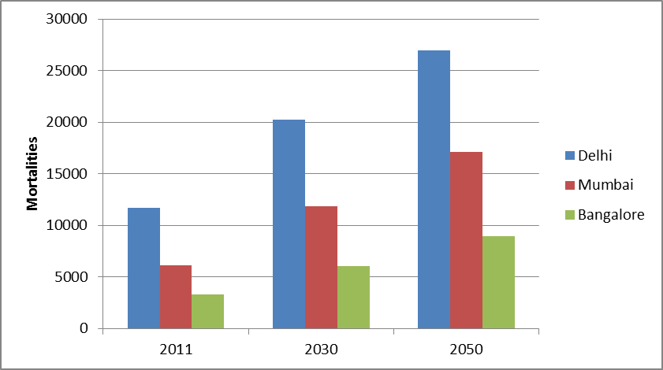

Figure 7 Mortalities estimated for the 3 selected cities for the baseline and future years in the BAU scenario

Figure 8 shows mortalities attributed to ambient air pollution per 1000 residents in the three cities and overall India, in different years of the BAU scenario. As the Indo-Gangetic plains is the more polluted zone in India, Mumbai and Bangalore show lower rate than India average. Delhi shows much higher rate than the India average.

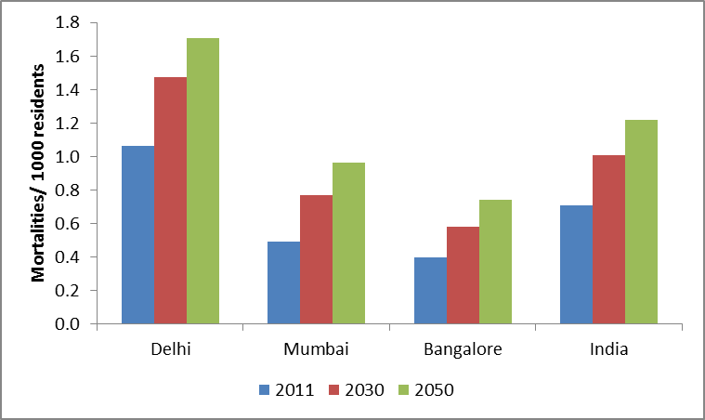
Figure 8 Mortalities attributed to ambient air pollution per 1000 residents in different years of the BAU scenario

The study clearly points to the worsening situation of air pollution and its health impacts in a scenario where no further interventions are made. It is evident that many more measures will be required to reduce emissions which can lead to reduction in pollutant concentrations and corresponding health impacts. Finally, in absence of comprehensive information on dose response relationships for India, the curves prepared in developed nations have been used, which needs to be improved in future research.
Bibliography
Anderson, J.O., Thundiyil, J.G., Stolbach, A., 2012. Clearing the air: a review of the effects of particulate matter air pollution on human health. Journal of Medicine Toxicology 8; 166–175.
Gent, J.F., Triche, E.W., Holford, T.R., Belanger, K., Bracken, M.B., Beckett, W.S., Leaderer, B.P., 2003. Association of low-level ozone and fine particles with respiratory symptoms in children with asthma. Journal of American Medical Association 290; 1859–1867.
Guttikunda, S., Goel, R., 2013. Health impacts of particulate pollution in a mega city – Delhi, India. Environmental Development 6; 8–20.
Hoek, G., Krishnan, R.M., Beelen, R., Peters, A., Ostro, B., Brunekreef, B., Kaufman, J.D., 2013. Long-term air pollution exposure and cardio-respiratory mortality: a review. Environmental Health 12; 23–35.
Laden, F., Schwartz, J., Speizer, F.E., Dockery, D.W., 2006. Reduction in fine particulate air pollution and mortality: Extended follow-up of the Harvard Six Cities study. American Journal of Respiratory and Critical Care Medicine 173; 667–672.
Leiva, G.M.A., Santibañez, D.A., Ibarra, E.S., Matus, C.P., Seguel, R., 2013. A five-year study of particulate matter (PM2.5) and cerebrovascular diseases. Environmental Pollution 181; 1–6.
McConnell, R., Berhane, K., Gilliland, F., London, S.J., Vora, H., Avol, E., Gauderman, Margolis, W.J., Lurmann, F., Thomas, D.C., Peters, J.M., 1999. Air pollution and bronchitic symptoms in Southern California children with asthma. Environmental Health Perspective 107:757–760.
Mustafić, H., Jabre, P., Caussin, C., Murad, M.H., Escolano, S., Tafflet, M., Périer, M.C., Marijon, E., Vernerey, D., Empana, J.P., Jouven, X., 2012. Main air pollutants and myocardial infarction: a systematic review and meta-analysis. Journal of American Medical Association 307; 713–721.
Peters, A., Liu, E., Verrier, R.L., Schwartz, J., Gold, D.R., Mittleman, M., Baliff, J., Oh, J.A., Allen, G., Monahan, K., Dockery, D.W., 2000. Air pollution and incidence of cardiac arrhythmia. Epidemiology 11; 11–17.
Pope, C.A. 3rd., Dockery, D.W., 2006. Health effects of fine particulate air pollution: lines that connect. Journal of Air and Waste Management Association 56; 709–742.
Pope, C.A. 3rd., Burnett, R.T., Thurston, G.D., Thun, M.J., Calle, E.E., Krewski, D., Godleski, J.J., 2004. Cardiovascular mortality and long-term exposure to particulate air pollution: epidemiological evidence of general pathophysiological pathways of disease. Circulation 109; 71–77
Pope, C.A.3rd., Dockery, D.W., 2006. Health effects of fine particulate air pollution: lines that connect. Journal of Air and Waste Management Association 56; 709–742.
Pope, C.A.3rd., Ezzati, M., Dockery, D.W., 2009. Fine-particulate air pollution and life expectancy in the United States. The New England Journal of Medicine 360; 376–386.
Pope, C.A.3rd., Burnett, R.T., Krewski, D., Jerrett, M., Shi, Y., Calle, E.E., Thun, M.J., 2009. Cardiovascular mortality and exposure to airborne fine particulate matter and cigarette smoke: shape of the exposure-response relationship. Circulation 120; 941–948.
Rabinovitch, N., Strand, M., Gelfand, E.W., 2006. Particulate levels are associated with early asthma worsening in children with persistent disease. American Journal of Respiratory and Critical Care Medicine 173; 1098–1105
Rückerl, R., Schneider, A., Breitner, S., Cyrys, J., Peters, A., 2011. Health effects of particulate air pollution: A review of epidemiological evidence. Inhalation Toxicology 23; 555–592.
Sacks, J.D., Stanek, L.W., Luben, T.J., Johns, D.O., Buckley, B.J., Brown, J.S., Ross, M., 2011. Particulate matter-induced health effects: who is susceptible? Environmental Health Perspective 119; 446–454.
Samoli, E., Analitis, A., Touloumi, G., Schwartz, J., Anderson, H.R., Sunyer, J., Bisanti, L., Zmirou, D., Vonk, J.M., Pekkanen, J., Goodman, P., Paldy, A., Schindler, C., Katsouyanni, K., 2005. Estimating the exposure-response relationships between particulate matter and mortality within the APHEA multicity project. Environmental Health Perspective 113; 88–95.
Schwartz, J., 2004. The effects of particulate air pollution on daily deaths: a multi-city case crossover analysis. Occupational and Environmental Medicine 61; 956–961
Shah, A.S.V., Langrish, J.P., Nair, H., McAllister, D.A., Hunter, A.L., Donaldson, K., Newby, D.E., Mills, N.L., 2013. Global association of air pollution and heart failure: a systematic review and meta-analysis. Lancet 382; 1039–1048.
Smith, K.R., Peel, J.L., 2010. Mind the gap. Environmental Health Perspective 118; 1643–1645.
Tillett, T., 2010. A break in the continuum: analyzing the gap in particle exposure research. Environmental Health Perspective 118; 543–555
Tsai, S.S., Chang, C.C., Yang, C.Y., 2013. Fine particulate air pollution and hospital admissions for chronic obstructive pulmonary disease: a case-crossover study in Taipei. International Journal of Environmental Research and Public Health 10; 6015–6026.
Turner, M.C., Krewski, D., Pope, C.A. 3rd., Chen, Y., Gapstur, S.M., Thun, M.J., 2011..Long-term ambient fine particulate matter air pollution and lung cancer in a large cohort of never-smokers. American Journal of Respiratory and Critical Care Medicine 184 (12); 1374–1381.
U.S. EPA., 2009. Integrated Science Assessment for Particulate Matter (Final Report). U.S. Environmental Protection Agency, Washington, DC
U.S. EPA., 2010. Quantitative health risk assessment for particulate matter. North Carolina: U.S. Environmental Protection Agency, Washington, DC
WHO, 2005. Effects of air pollution on children’s health and development: a review of the evidence. Special programme on health and development. European Center for environment and health. Bonn, Germany: World Health Organization.
WHO., 2005. Effects of air pollution on children’s health and development: a review of the evidence. Special programme on health and development. European Center for environment and health. Bonn, Germany: World Health Organization.
Zanobetti, A., Schwartz, J., 2009. The effect of fine and coarse particulate air pollution on mortality: a national analysis. Environmental Health Perspective 117; 898–903.

